Project Design Phase-I
Solution Architecture

Date | 28 October 2026
Team ID | Team ID: To be filled
Project Name | Global Fuel Prices and Taxation Trends (2020–2025)
Maximum Marks | 4 Marks

Solution Architecture:
Solution architecture is a complex process – with many sub-processes – that bridges the gap between business problems and technology solutions. Its goals are to:
- Find the best tech solution to solve existing business problems.
- Describe the structure, characteristics, behavior, and other aspects of the software to project stakeholders.
- Define features, development phases, and solution requirements.
- Provide specifications according to which the solution is defined, managed, and delivered.

Sample Solution Architecture Diagram:
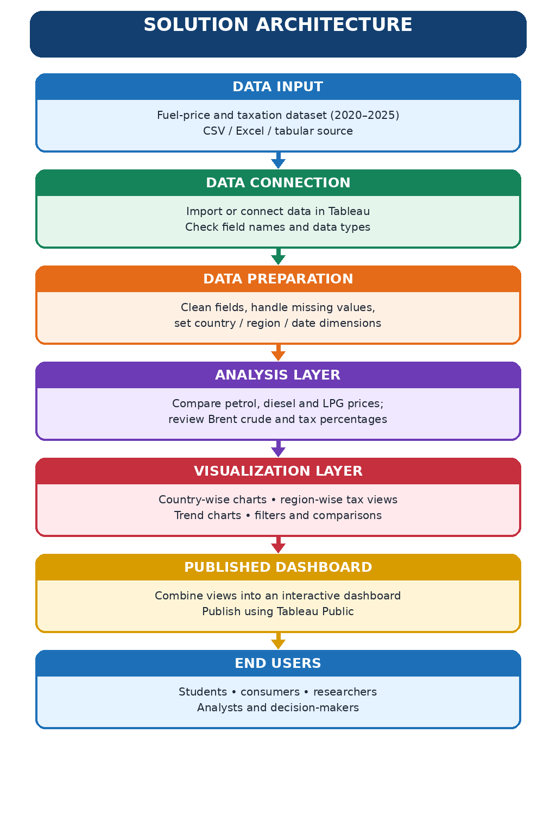

Component Description Table
Component Name | Description / Role in Architecture | Technology Used
Data Source | Contains the project data for fuel prices, crude oil and taxation across countries/regions for 2020–2025. | CSV / Excel / tabular dataset
Data Preparation | Connects the data, checks field types and prepares country, region, date and numeric measures for analysis. | Tableau data connection and preparation tools
Analysis & Visualization | Creates country-wise fuel comparisons, Brent crude trends, tax-percentage comparisons and interactive dashboard views. | Tableau Public / Tableau

